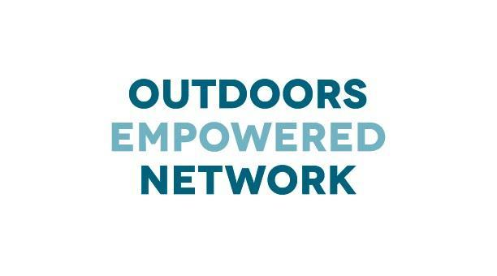
CONTACT:
Shea Morrissey
Outdoors Empowered Network
shea@outdoorsempowered.org

Forest Preserve District of Cook County Joins Outdoors Empowered Network
Chicago launches Camping Leadership Immersion Course to get kids outdoors

SAN FRANCISCO – January 25, 2016 – Outdoors Empowered Network (OEN), the largest national network of Member Organizations through which educators and youth leaders have access to wilderness training and free outdoor gear libraries, welcomes the Forest Preserve of Cook County (FPCC), of Chicago, Ill., as the first member program in the Midwest. Chicago joins Los Angeles, the San Francisco Bay Area, Boise, and Seattle in a growing number of cities with programs increasing much needed access to nature for youth. In 2015 alone, OEN’s programs have trained 318 youth leaders and empowered 10,000 youth participants to experience the outdoors through immersive backpacking and camping trips.

The FPCC is the first government agency and land manager to join the OEN, and is emerging as a national leader in the creation of programs to support their use by youth, families and community-based organizations. The Camping Leadership Immersion Course (CLIC), a program developed by the FPCC with support from OEN, provides a dynamic and affordable way to enrich the lives of young people through outdoor recreation and education. The goal of the CLIC program in the Chicagoland area, and that of the other OEN supported initiatives nationwide, is to provide outdoor experiences to youth who don’t often access public lands and overnight camping.

“In 2015, the Forest Preserves of Cook County brought back public camping for the first time in fifty years with the opening of five new and revitalized campgrounds ,” said Arnold Randall, General Superintendent of the FPCC. “Despite being within the footprint of the third largest metropolis in the country, the FPCC manages more than 70,000 acres of natural land. Offering the CLIC program so close to an urban area is a valuable resource. Our partnership with OEN makes it possible for us to expose and immerse new and diverse audiences to camping, which can be a gateway to healthy and active living.”

Through OEN’s programs, which help provide organizations with a blue-print for success to train leaders and build gear libraries, participants in programs like the CLIC are provided with access to all the gear they need to have a fun, safe, and meaningful camping experience: tents, sleeping bags, sleeping pads, kitchen kits, and the appropriate outerwear. Through key partnerships, the hard work of staff, and the helping hands of many volunteers, programs like these aspire to redefine the accessibility and relationship to the outdoors for the nation’s youth.

Thus far the CLIC program in Chicago has successfully trained 43 individuals, representing 33 different organizations, ranging from schools to scout leaders. In the first season, there were 68 youth participants, the vast majority of whom were first time campers that wouldn’t otherwise have access to camping gear.

"Not only did the staff walk us through best practices, but enabled us to participate in the activities we would eventually be leading with our own teens,” said Judy Idrovo, CLIC participant from Mujeres Latinas en Accion-Proyecto Juventud. “This experience made camping with my youth team and teens enjoyable, adventurous, and unforgettable since I was able to rely on the knowledge I had gained through my training.”

OEN’s model of providing trainings to youth serving organizations, programming support and development of gear libraries across is effective, adaptive and replicable. Interested in bringing a gear library and training program to your city? Contact Kyle Macdonald at 415-516-9919 or info@outdoorsempowered.org.

ABOUT OUTDOORS EMPOWERED NETWORK
Outdoors Empowered Network is a growing national network of Member Organizations that get youth outdoors by providing youth workers with wilderness leadership training and access to free outdoor Gear Libraries. Our Network Members are creating access to nature for tens of thousands of kids annually. The Network provides its Members with backbone organizational support including an array of support services, a National Summit, and gear for their lending libraries. www.outdoorsempowered.org

